**Supplementary Material**

Supplementary Methods

*Figure S1. A screenshot of the grids in which participants reported their types of synaesthesia*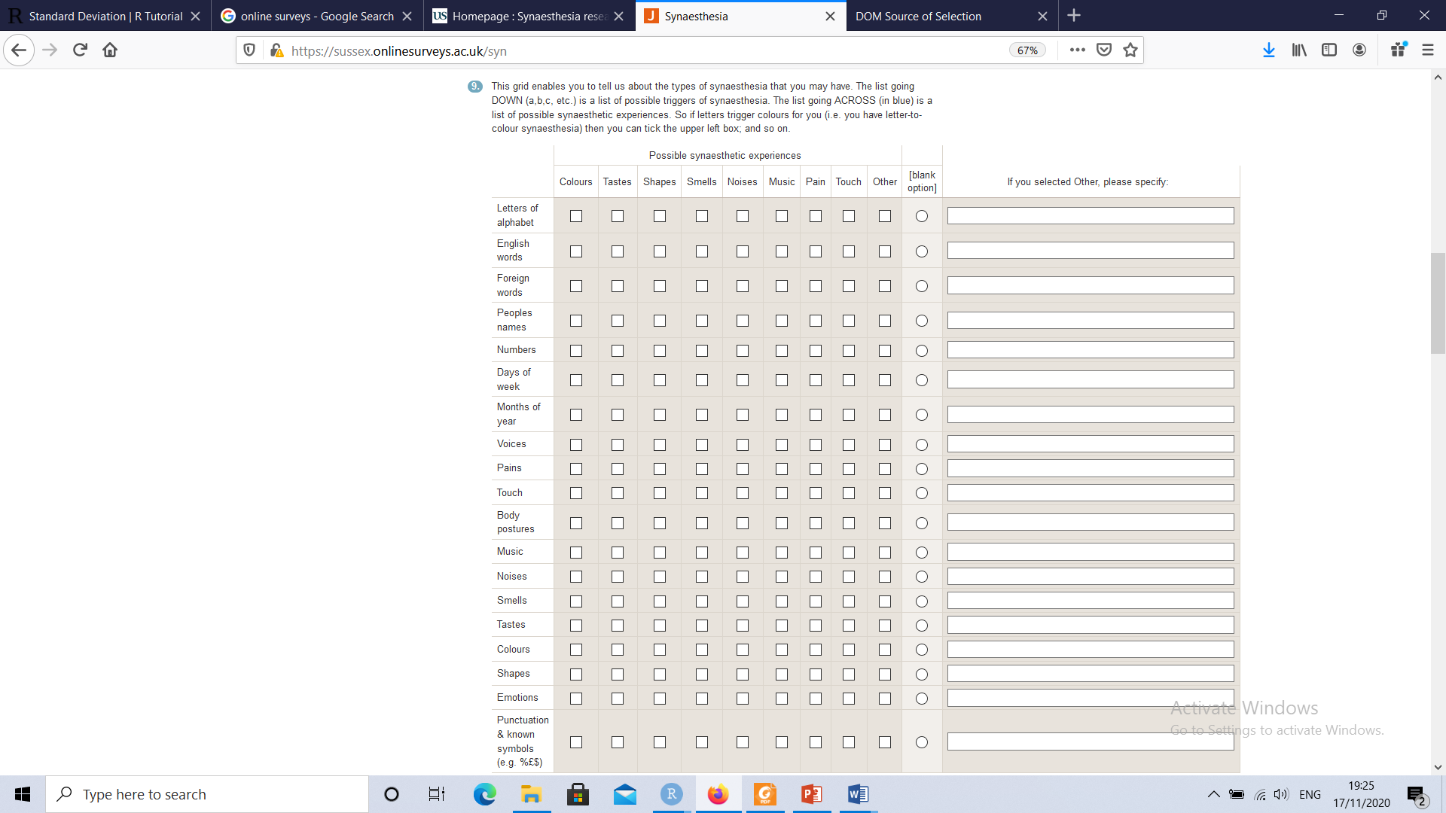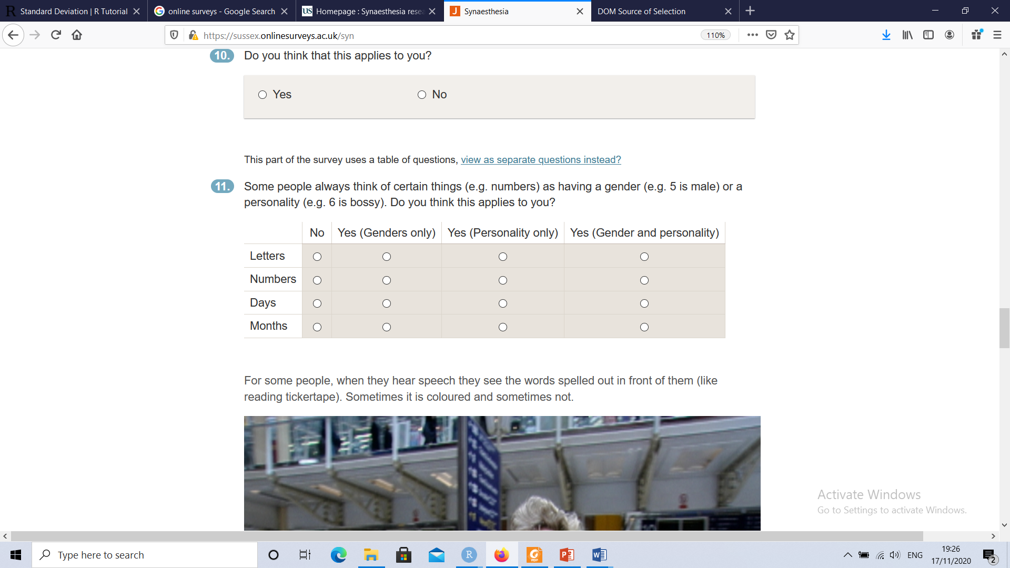

*Figure S2. Images used in the screening questionnaire to illustrate sequence-space synaesthesia (top and middle) and tickertape synaesthesia (bottom). The links to the videos for mirror-touch and hearing-motion are* [*https://youtu.be/aoUdvuLrawE*](https://youtu.be/aoUdvuLrawE) *and* [*https://youtu.be/o39TiACe4mw*](https://youtu.be/o39TiACe4mw)

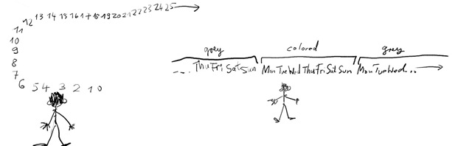

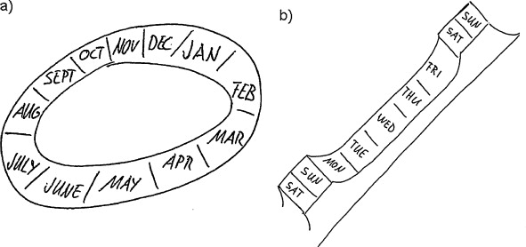

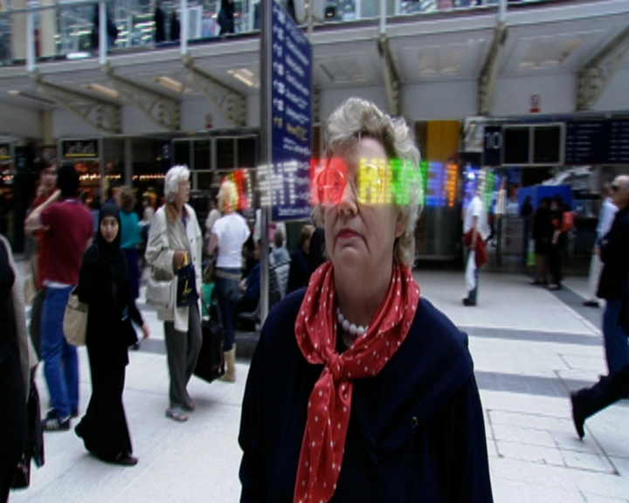

Supplementary Results

*Figure S3. Full dendrogram of all N=164 types of synaesthesia in the Inclusive dataset. The colours and labels for the different branches reflect the judgment of the authors.*

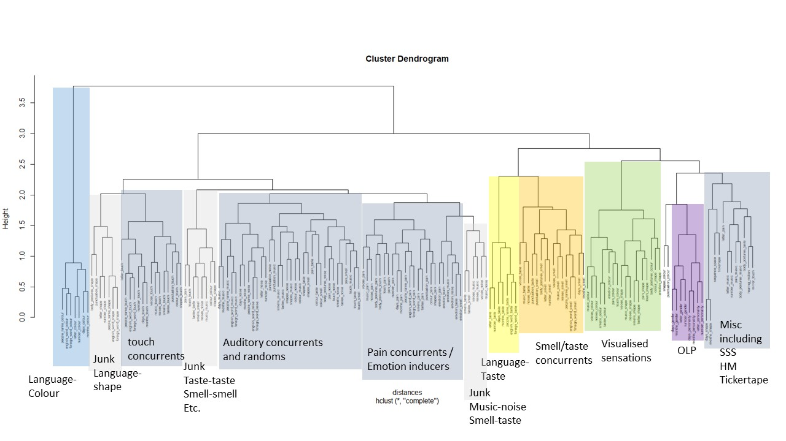

*Figure S4. Full dendrogram of all N=112 types of synaesthesia in the Stringent dataset. The colours and labels for the different branches reflect the judgment of the authors. The ‘cut lines’ show how different numbers of clusters are obtained.*

